CMPG325 – COMPUTER NETWORKS
INDIVIDUAL SEMESTER PROJECT

1.CLIENT REQUIREMENTS
Project Information:
Item | Details
Student | Molekwa, ER
Student Number | 45618070
Project ID | CMPG325-2026-082
Client ID | CLI-082
Organisation | Ramokoka & Partners Attorneys (Vryburg)
Industry | Legal Services
Assigned Addressing Block | 172.30.52.0/23
Assigned Networking Challenge | ACLs – Traffic Filtering Policy
Design Constraint | Wireless coverage required only in specified public areas
Change Request | CR6 – Branch office planned; design/addressing accommodation only; no second-site build required
Simulation Platform | Cisco Packet Tracer

- INTRODUCTION
This project presents the proposed network design for Ramokoka & Partners Attorneys (Vryburg). The design aims to provide a secure, manageable and scalable network that meets the organisation’s requirements. It includes the analysis of client requirements, the development of physical and logical network topologies, and an IP addressing plan based on the assigned 172.30.52.0/23 address block. The network uses VLAN segmentation, inter-VLAN routing and an ACL traffic-filtering policy to control access between network segments, particularly the public wireless network. The design also accommodates CR6 by reserving address space for a future branch office without implementing a second site.

- CLIENT REQUIREMENTS

- Client Overview
Ramokoka & Partners Attorneys is a legal-services organisation based in Vryburg. The purpose of the project is to design and simulate a computer network that provides appropriate connectivity and network services for the organisation while satisfying the requirements, constraints and change request specified in the project brief.
The network must support the organisation's operational requirements while providing controlled access to network resources. As a legal-services organisation, appropriate protection of confidential organisational and client-related information is an important consideration in the network design.
The proposed network will be designed and simulated using Cisco Packet Tracer. The assigned IPv4 addressing block, 172.30.52.0/23, will form the basis of the IP addressing plan.
The network design must remain specific to Ramokoka & Partners Attorneys (Vryburg) and must not introduce an alternative client scenario.

- Client Network Requirements
The network solution shall satisfy the following requirements:
- Provide appropriate wired network connectivity within the Vryburg office.
- Provide appropriate connectivity between authorised network devices and resources.
- Provide wireless connectivity only within the specified public areas.
- Provide appropriate network services required by the final network design.
- Use the assigned 172.30.52.0/23 address block as the basis for IPv4 addressing.
- Provide logical control over communication between relevant network segments.
- Implement and demonstrate the assigned ACL traffic-filtering policy.
- Permit legitimate and required network traffic while restricting unauthorised traffic.
- Provide sufficient addressing capacity for the current office and planned future expansion.
- Accommodate CR6, the planned branch office, through network design and addressing only.
- Provide a working and testable Cisco Packet Tracer implementation.
- Provide documented evidence of configuration, testing and troubleshooting.
- Maintain an individual GitHub portfolio containing appropriate project evidence.
- Provide a final technical demonstration through the required 15–20 minute individual video.

- Functional Network Requirements
Wired Network Connectivity
The network shall provide reliable wired connectivity for authorised users, infrastructure devices and other required network nodes within the Vryburg office.
The wired network shall allow authorised devices to communicate with required network resources while maintaining appropriate traffic controls between network areas.
The final device selection and number of end devices will be determined during the physical and logical network design stages according to the requirements of the simulated organisation.
Internal Network Communication
The network shall support communication between appropriate internal network segments.
Where logical network segmentation is implemented, routing shall provide communication between networks where such communication is required. Traffic that should not be permitted between network segments shall be controlled through appropriate traffic-filtering policies.
The network design shall therefore balance connectivity, security and controlled access rather than allowing unrestricted communication between all network segments.
Network Services
The network shall provide the network services required for the effective operation of the simulated organisation.
Depending on the final design, appropriate services may include:
- IP address allocation;
- default gateway services;
- routing between required networks;
- DNS or other supporting network services where justified; and
- other services that provide a clear benefit to the client's requirements.
Only services that have a clear technical purpose within the client scenario shall be included in the final implementation.

- Public-Area Wireless Requirement
The project brief specifies the following design constraint:
Wireless coverage required only in specified public areas.
Wireless connectivity shall therefore be limited to the public areas identified by the final network design.
The wireless network shall not unnecessarily extend coverage to areas that are not intended for public wireless access.
Public wireless traffic shall be logically separated from protected internal network resources where required. Appropriate traffic-filtering controls shall be applied to prevent public users from accessing resources that they are not authorised to access.
The final physical topology shall identify the wireless equipment and its connection to the network.

- Network Security Requirements
Security is an important consideration because the organisation operates within the legal-services industry and may handle confidential organisational and client-related information.
The network design shall therefore provide controlled access to network resources.
The security requirements include:
- preventing unnecessary access between network segments;
- controlling public wireless access to internal resources;
- restricting unauthorised traffic;
- permitting required communication between authorised network nodes;
- implementing the assigned ACL traffic-filtering policy;
- verifying the effectiveness of the security controls through testing; and
- documenting significant security-related design decisions.
Logical segmentation may be used where it provides a clear security, management or traffic-control benefit. The final segmentation structure shall be determined and justified during the logical topology design stage.

- Assigned Networking Challenge – ACLs
The assigned technical networking challenge for the project is:
ACLs – Traffic Filtering Policy
An appropriate Access Control List implementation shall be incorporated into the network.
The ACL implementation shall:
- control traffic according to the defined network security requirements;
- permit required communication;
- deny inappropriate or unauthorised communication;
- be applied to an appropriate Layer 3 interface or device;
- be integrated with the logical network design;
- be verified using appropriate Cisco commands; and
- be tested using relevant end-to-end connectivity tests.
The ACL shall not be implemented as an isolated configuration. Its rules shall be based on the actual traffic requirements of the designed network. Testing shall demonstrate both permitted and restricted traffic.
For example:
Traffic Type | Expected Result
Authorised traffic : | Permitted
Required internal communication : | Permitted
Unauthorised access to protected resources : | Denied
Restricted public-to-internal traffic : | Denied

The final ACL policy and exact rules will be determined after the logical network structure and addressing plan have been established.
- IP Addressing Requirements
The organisation has been assigned the IPv4 address block:
172.30.52.0/23
This address block shall form the basis of the network's IP addressing plan.
The addressing design shall:
- allocate suitable subnets to the required network segments;
- provide appropriate default gateway addresses;
- allocate addresses efficiently;
- provide suitable addresses for network infrastructure;
- provide sufficient host capacity for current requirements;
- allow for future network expansion; and
- accommodate the planned branch office specified by CR6.
The IP addressing plan shall be documented separately and shall correspond directly with the physical and logical topology.
Address allocation shall be structured in a way that makes the network easier to understand, administer, troubleshoot and expand.

Future Branch Office Requirement – CR6
The client change request is:
CR6: Branch office planned – design/addressing accommodation only; no second-site build required.
The network design shall therefore provide accommodation for a future branch office without implementing a second physical site.
The current Packet Tracer implementation shall remain focused on the Ramokoka & Partners Attorneys Vryburg office.
Future branch-office requirements shall be accommodated through:
- appropriate IP addressing planning;
- reservation of sufficient addressing capacity;
- consideration of future subnet requirements;
- scalable network design; and
- an addressing structure that can be extended when the branch is eventually implemented.

Scope restriction
No second-site branch-office topology shall be constructed in Cisco Packet Tracer.
No second physical branch network shall be implemented as part of this project.
The branch-office requirement is limited to design and addressing accommodation.

- Network Design Requirements
The proposed network shall:
- use Cisco Packet Tracer for implementation and simulation;
- provide an appropriate physical topology;
- provide an appropriate logical topology;
- use the assigned 172.30.52.0/23 address block;
- include suitable network devices for the final design;
- include appropriate end devices;
- provide suitable wired connectivity;
- provide wireless connectivity only within specified public areas;
- provide appropriate network services;
- support communication between authorised network segments;
- implement the assigned ACL traffic-filtering policy;
- accommodate the future branch office through design and addressing;
- support effective testing and verification; and
- remain within the scope of the assigned client scenario.
Device selection shall be based on functionality and suitability rather than adding unnecessary equipment or technologies.
Connectivity and Testing Requirements
The completed Packet Tracer network shall demonstrate successful communication between appropriate network nodes.
Testing shall include relevant:
- end-to-end connectivity tests;
- default gateway tests;
- communication between authorised network segments;
- network-service connectivity tests where applicable;
- public wireless connectivity tests;
- ACL permit tests; and
- ACL deny tests.
The ACL implementation shall be tested from both permitted and restricted traffic perspectives.
Example testing objectives
Permitted traffic:
A device requiring access to an authorised network resource should successfully communicate with that resource.
Restricted traffic:
A public or otherwise unauthorised device attempting to access a protected internal resource should be prevented from communicating with that resource.
Appropriate Cisco verification commands shall also be used to confirm that configurations and network states are correct.
Testing results shall be documented and supported with screenshots or other appropriate evidence.

- Troubleshooting Requirements
Important troubleshooting performed during the implementation shall be documented.
Troubleshooting evidence may include:
- identification of connectivity problems;
- identification of incorrect configurations;
- correction of configuration errors;
- verification after corrections;
- relevant command output; and
- screenshots showing successful operation after troubleshooting.
The troubleshooting record shall demonstrate the development and verification of the network rather than only presenting the final working state.

- GitHub Portfolio Requirements
An individual GitHub portfolio shall be maintained throughout the project.
The repository shall provide organised and professional evidence of the development process.
The portfolio shall contain appropriate evidence relating to:
- client requirements;
- network design;
- physical topology;
- logical topology;
- IP addressing;
- Cisco Packet Tracer implementation;
- device configuration;
- ACL configuration;
- testing;
- troubleshooting;
- screenshots;
- technical documentation;
- project development;
- reflection; and
- other relevant project evidence.
The repository shall use meaningful commit messages that clearly demonstrate project development over time.
The repository shall be professionally structured and easy to navigate.

- Evidence Requirements
Evidence shall be collected throughout the project rather than only at final submission.
Relevant evidence include:
- physical topology screenshots;
- logical topology diagrams;
- IP addressing tables;
- Packet Tracer configuration screenshots;
- CLI configuration output;
- ACL configuration and verification;
- successful ping results;
- failed or blocked connectivity tests;
- troubleshooting evidence;
- GitHub commit history;
- final network implementation; and
- other evidence demonstrating compliance with the project requirements.
Evidence shall clearly correspond to the requirement or technical feature being demonstrated.

- Individual Video Demonstration Requirements
A 15–20 minute individual video demonstration shall be submitted with an inset webcam view.
The demonstration shall include:
- Introduction of the student.
- Introduction of Ramokoka & Partners Attorneys (Vryburg).
- Explanation of the client requirements.
- Explanation of the physical network design.
- Explanation of the logical network design.
- Explanation of the IP addressing plan.
- Demonstration of the Cisco Packet Tracer implementation.
- Demonstration of the assigned ACL challenge.
- Demonstration of relevant configuration.
- Demonstration of connectivity testing.
- Demonstration of ACL permit and deny testing.
- Discussion of significant design decisions.
- Discussion of important troubleshooting performed.
- Short reflection on the completed project.
The demonstration shall show technical understanding of the implemented solution. Design and configuration decisions shall be justified rather than merely demonstrated.

- Project Scope
Included in Scope
The project includes:
- Ramokoka & Partners Attorneys (Vryburg);
- current office network design;
- physical network topology;
- logical network topology;
- IPv4 addressing using 172.30.52.0/23;
- appropriate wired connectivity;
- wireless connectivity within specified public areas;
- appropriate network services;
- network segmentation where justified;
- ACL traffic filtering;
- connectivity testing;
- ACL verification;
- troubleshooting;
- Cisco Packet Tracer simulation;
- GitHub documentation;
- technical evidence;
- future branch-office design and addressing accommodation; and
- individual video demonstration.
Excluded from Scope
The following are outside the project scope:
- construction of a second physical branch office;
- implementation of a second-site Packet Tracer topology;
- unrelated client scenarios;
- unnecessary networking technologies;
- unnecessary network services; and
- functionality not justified by the assigned client requirements.
The project shall remain specific to Ramokoka & Partners Attorneys (Vryburg) and the requirements provided in the assigned project brief.

- Design Principles
The following principles shall guide the development of the network.
- Security
Network access shall be controlled according to the communication requirements of the organisation. Unauthorised traffic shall be restricted through appropriate network controls.
- Segmentation
Logical network segmentation shall be used where it provides a clear security, management or traffic-control benefit.
- Efficiency
The assigned 172.30.52.0/23 address block shall be allocated efficiently according to the requirements of the network.
- Scalability
The network shall provide sufficient capacity for current requirements while allowing future expansion and accommodation of the planned branch office.
- Simplicity
Only devices, services and technologies that have a clear technical purpose shall be included in the final implementation.
- Reliability
The network shall be designed to provide stable connectivity between required devices and network resources.
- Verifiability
Major configurations and technical features shall be capable of being tested and verified using appropriate methods.
- Scope Control
The design shall remain within the requirements of the assigned client and shall not introduce an unnecessary second-site implementation or unrelated functionality.

- Requirements Summary
Client Requirement | Network Design Response
Office connectivity | Provide suitable wired network connectivity for authorised devices
Public-area wireless | Provide wireless coverage only within specified public areas
Network organisation | Apply logical segmentation where justified by the network requirements
Traffic control | Implement ACLs to control permitted and restricted traffic
IP addressing | Use 172.30.52.0/23 as the assigned IPv4 addressing block
Network services | Provide only services justified by the final network design
Security | Control access between relevant network areas and resources
Future branch | Reserve and plan addressing capacity for CR6
Second site | No second-site implementation
Connectivity testing | Test relevant end-to-end communication
ACL testing | Demonstrate both permitted and denied traffic
Verification | Use appropriate Cisco verification commands
Troubleshooting | Document significant configuration and connectivity problems and their resolution
Packet Tracer | Implement and simulate the network in Cisco Packet Tracer
GitHub | Maintain an individual professional evidence portfolio
Video | Submit a 15–20 minute individual demonstration with inset webcam
Final submission | Submit the required project files, GitHub portfolio, technical documentation and video through eFundi

- Client Requirements Conclusion
The client requirements establish the foundation for the network design and implementation of Ramokoka & Partners Attorneys (Vryburg).
The proposed network solution shall provide appropriate office connectivity, controlled access to network resources, public-area wireless connectivity, efficient use of the assigned 172.30.52.0/23 address block and implementation of the assigned ACL traffic-filtering policy.
The network shall also provide a scalable design capable of accommodating the client's CR6 planned branch office through addressing and design considerations without implementing a second physical site.
The requirements defined in this document provide the basis for the subsequent physical topology, logical topology, IP addressing plan and Cisco Packet Tracer implementation. All major design decisions shall be justified against the client's requirements, technical constraints and project scope.

2. PHYSICAL TOPOLOGY
2.1 Physical Topology Diagram
The physical network topology for Ramokoka & Partners Attorneys (Vryburg) was designed using a hierarchical star structure suitable for a small professional office environment. The topology provides a centralised network structure in which the Layer 3 core switch connects the edge router, access switches and shared network resources.
The design consists of an edge router connected to a Layer 3 core switch, with two Layer 2 access switches providing connectivity for the internal staff network and the public wireless network respectively. The network server and shared network printer are connected directly to the core switch. All staff workstations are physically connected to the internal access switch, while the wireless access point is connected through the public access switch.
The physical topology is shown below.
Figure 1: Physical Network Topology – Ramokoka & Partners Attorneys (Vryburg)

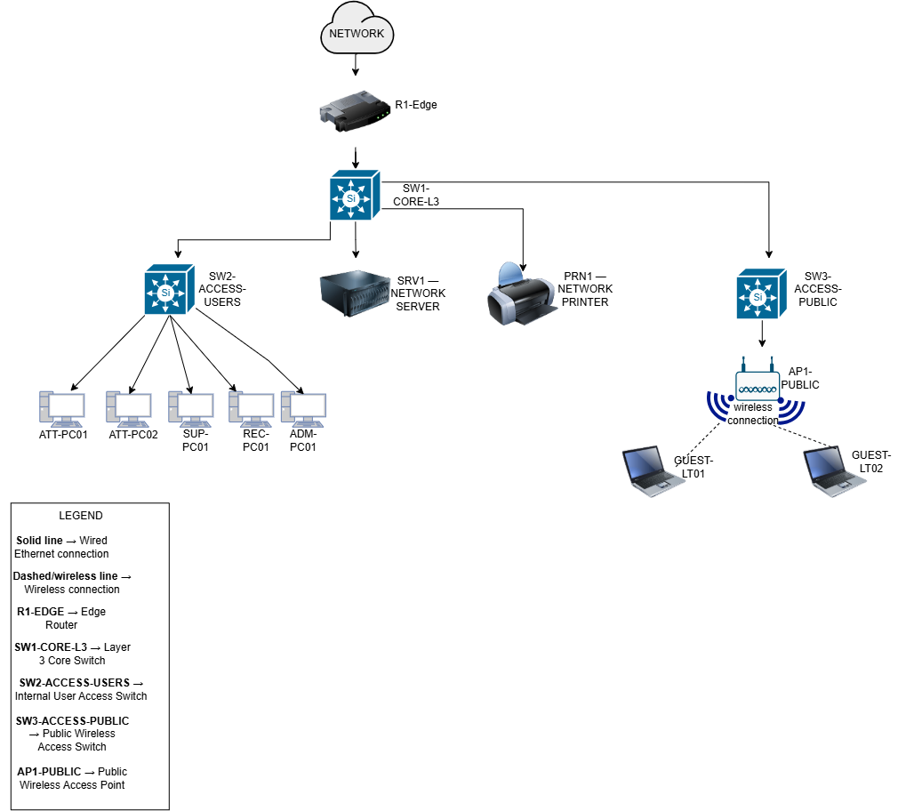

The physical topology represents only the current Vryburg office. In accordance with Change Request CR6, no physical network infrastructure for the planned future branch office is included. Future branch requirements are accommodated through network design and IP address reservation only.

2.2 Device Overview
The physical network consists of the following networking devices and end devices:
Device | Quantity | Function
R1-EDGE | 1 | Provides the connection between the internal organisational network and the external/ISP network.
SW1-CORE-L3 | 1 | Serves as the central Layer 3 core switch and provides the foundation for inter-VLAN routing and ACL enforcement.
SW2-ACCESS-USERS | 1 | Provides wired network connectivity for all internal staff workstations.
SW3-ACCESS-PUBLIC | 1 | Provides the physical network connection for the public wireless access point and separates the public wireless access infrastructure from the internal staff access switch.
SRV1 | 1 | Provides centralised network services required by the network design, including DHCP services.
PRN1 | 1 | Provides a shared network printing resource for authorised internal users.
AP1-PUBLIC | 1 | Provides wireless connectivity in the specified public areas of the organisation.
Attorney Workstations | 4 | Represent the wired workstations used for attorney-related network access within the simulated environment.
Support Workstations | 2 | Represent wired workstations used for support/paralegal functions within the simulated environment.
Reception Workstation | 1 | Represents the wired workstation used for the reception function.
Administration Workstation | 1 | Represents the wired workstation used for administrative functions.
Guest Laptops | 2 | Represent wireless client devices used to test connectivity and access restrictions on the public wireless network.

The eight staff workstations are connected to SW2-ACCESS-USERS. The staff endpoints consist of four attorney workstations (ATT-PC01 to ATT-PC04), two support workstations (SUP-PC01 and SUP-PC02), one reception workstation (REC-PC01) and one administration workstation (ADM-PC01). These devices represent the network roles required for the simulation and should not be interpreted as the organisation's confirmed employee headcount.
The two guest laptops (GUEST-LT01 and GUEST-LT02) connect wirelessly through AP1-PUBLIC. They are included to demonstrate and test public wireless connectivity and the traffic restrictions that will later be implemented using Access Control Lists.

2.3 Physical Design Justification
A hierarchical star topology was selected because it provides a simple, manageable and scalable structure for the Vryburg office. SW1-CORE-L3 acts as the central network device, while the access switches provide connectivity to different groups of network endpoints. This arrangement simplifies network administration and allows faults or changes within one access segment to be managed without unnecessarily affecting the entire network.
R1-EDGE is positioned between the internal network and the external/ISP network to provide an appropriate boundary between internal and external connectivity. SW1-CORE-L3 is used as the central Layer 3 device because the logical network requires multiple VLANs and inter-VLAN communication. It also provides an appropriate enforcement point for the project's assigned ACL traffic-filtering policy, since traffic moving between VLANs can be controlled at the Layer 3 core.
All internal staff workstations are physically connected to SW2-ACCESS-USERS. Although these devices share the same physical access switch, they can later be separated logically into different VLANs according to their organisational functions. This approach avoids unnecessary physical switches while still providing logical segmentation and traffic control.
SW3-ACCESS-PUBLIC is dedicated to the public wireless access infrastructure. AP1-PUBLIC connects to this switch and provides wireless access only within the specified public areas. Separating the public wireless access infrastructure from the internal staff access switch provides a clear physical and logical boundary that supports the security requirements of the network. Public wireless clients will subsequently be placed in a dedicated VLAN and restricted from accessing protected internal networks through ACLs.
SRV1 and PRN1 are connected directly to SW1-CORE-L3 because they are shared network resources that may need to be reached by authorised users from different internal VLANs. Their central placement provides a straightforward path to these services while allowing access to be controlled through the Layer 3 core.
The physical design also considers future expansion. Additional endpoints can be accommodated using available switch capacity, while the hierarchical structure allows the network to be extended without redesigning the entire topology. The future branch office specified by CR6 is intentionally excluded from the physical topology because the change request requires design and addressing accommodation only. Address space for the future branch is therefore reserved in the IP addressing plan without implementing second-site devices.
Overall, the physical topology was designed to provide an appropriate balance between security, manageability, scalability, simplicity and scope control for the current Ramokoka & Partners Attorneys Vryburg office network.

3. LOGICAL TOPOLOGY
3.1 Logical Topology Diagram
The logical topology for Ramokoka & Partners Attorneys (Vryburg) defines how network traffic is organised and controlled independently of the physical location of the devices. The network is logically segmented using Virtual Local Area Networks (VLANs) to separate different user groups, shared services, public wireless users and network-management traffic.
The Layer 3 core switch, SW1-CORE-L3, forms the central point of the logical topology. It provides Switch Virtual Interfaces (SVIs) that act as the default gateways for the VLANs and performs inter-VLAN routing. The design also provides a suitable point for implementing the assigned Access Control List (ACL) traffic-filtering policy.
The logical topology is shown below.
Figure 2: Logical Network Topology – Ramokoka & Partners Attorneys (Vryburg)
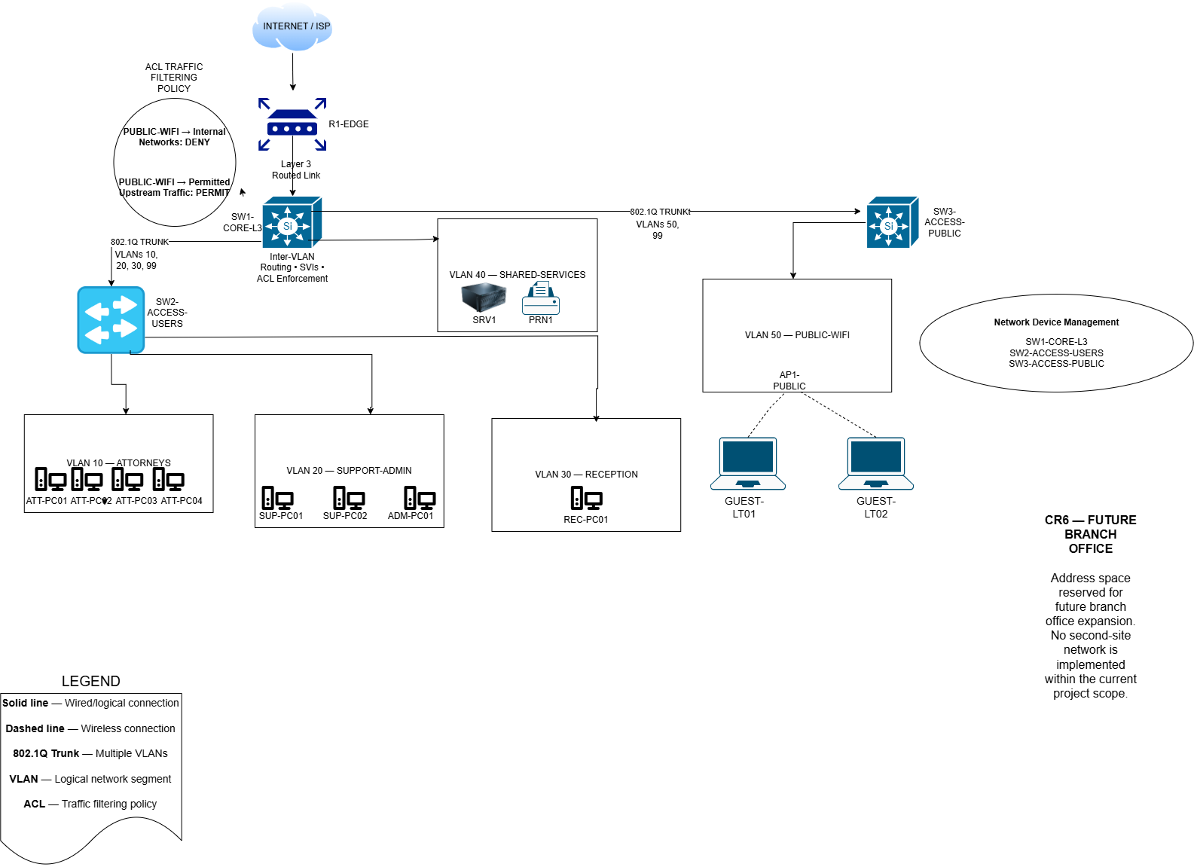

The logical topology separates the network into six VLANs: Attorneys, Support/Administration, Reception, Shared Services, Public Wi-Fi and Network Management. This segmentation improves traffic organisation, simplifies management and provides logical boundaries on which security policies can be applied.

3.2 VLAN Structure
Six VLANs are used to divide the network according to organisational and technical functions.
VLAN ID | VLAN Name | Purpose | Associated Devices
10 | ATTORNEYS | Provides the logical network for attorney workstations. | ATT-PC01, ATT-PC02, ATT-PC03, ATT-PC04
20 | SUPPORT-ADMIN | Provides the logical network for support/paralegal and administration workstations. | SUP-PC01, SUP-PC02, ADM-PC01
30 | RECEPTION | Provides a separate logical network for the public-facing reception function. | REC-PC01
40 | SHARED-SERVICES | Provides a central logical network for shared organisational network resources. | SRV1, PRN1
50 | PUBLIC-WIFI | Provides an isolated logical network for public wireless access. | AP1-PUBLIC, GUEST-LT01, GUEST-LT02
99 | MANAGEMENT | Provides a dedicated logical network for management of network infrastructure. | SW1-CORE-L3, SW2-ACCESS-USERS, SW3-ACCESS-PUBLIC

VLAN 10 – ATTORNEYS
VLAN 10 contains the four simulated attorney workstations. Separating attorney devices into their own logical network provides an identifiable security boundary and allows traffic associated with these workstations to be controlled independently of other user groups where required.
VLAN 20 – SUPPORT-ADMIN
VLAN 20 contains the two support/paralegal workstations and the administration workstation. These devices are grouped because they perform internal support and administrative functions. Combining them avoids unnecessary VLAN complexity while maintaining separation from attorney, reception and public wireless traffic.
VLAN 30 – RECEPTION
VLAN 30 contains the reception workstation. Reception performs a public-facing organisational function and is therefore separated logically from the other internal staff groups. This design also allows traffic associated with reception to be controlled independently if required.
VLAN 40 – SHARED-SERVICES
VLAN 40 contains SRV1 and PRN1. These resources may need to be accessed by authorised users from multiple internal VLANs. Placing them in a dedicated shared-services VLAN provides centralised access while keeping shared infrastructure separate from ordinary end-user networks.
VLAN 50 – PUBLIC-WIFI
VLAN 50 contains AP1-PUBLIC and the public wireless client devices. This VLAN is particularly important to the network's security design because public wireless clients must remain separated from protected internal resources. Traffic originating from this network will therefore be controlled using the assigned ACL traffic-filtering policy.
VLAN 99 – MANAGEMENT
VLAN 99 is reserved for management of network infrastructure. The management interfaces of SW1-CORE-L3, SW2-ACCESS-USERS and SW3-ACCESS-PUBLIC are associated with this VLAN. Ordinary user workstations and public wireless clients are not placed in the management VLAN.

3.3 Inter-VLAN Routing
Devices located in different VLANs belong to separate IP networks and therefore require a Layer 3 device to communicate with one another. In this design, inter-VLAN routing is performed by SW1-CORE-L3, the Cisco multilayer core switch.
A Switch Virtual Interface (SVI) is configured on SW1-CORE-L3 for each VLAN requiring Layer 3 connectivity. The SVI address acts as the default gateway for devices within that VLAN.
The planned SVI gateway addresses are:
VLAN | Network | SVI / Default Gateway
VLAN 10 – Attorneys | 172.30.52.32/28 | 172.30.52.33
VLAN 20 – Support/Admin | 172.30.52.48/28 | 172.30.52.49
VLAN 30 – Reception | 172.30.52.64/29 | 172.30.52.65
VLAN 40 – Shared Services | 172.30.52.72/29 | 172.30.52.73
VLAN 50 – Public Wi-Fi | 172.30.52.0/27 | 172.30.52.1
VLAN 99 – Management | 172.30.52.80/29 | 172.30.52.81

For example, when a device in VLAN 10 needs to communicate with an authorised resource in VLAN 40, the traffic is forwarded to the VLAN 10 SVI on SW1-CORE-L3. The Layer 3 switch then makes the routing decision and forwards the traffic toward VLAN 40, subject to any applicable security policy.
Using the multilayer core switch for inter-VLAN routing avoids the need to send all internal VLAN traffic through the edge router. R1-EDGE is instead used primarily to provide the routed path between the internal network and the upstream/external network.
The connection between SW1-CORE-L3 and R1-EDGE uses the dedicated 172.30.52.88/30 routed subnet, with 172.30.52.89 assigned to the core-switch side and 172.30.52.90 assigned to the edge-router side.

3.4 ACL Placement
The project's assigned networking challenge is the implementation of an Access Control List (ACL) traffic-filtering policy. The logical topology was designed so that ACL enforcement can be performed at SW1-CORE-L3, where traffic between the different VLANs is routed.
A primary security requirement of the logical design is to isolate the PUBLIC-WIFI VLAN (VLAN 50) from protected internal organisational networks. Public wireless clients should not be able to initiate access to the Attorneys, Support/Administration, Reception, Shared Services or Network Management networks.
The planned high-level policy is:
Source | Destination | Action
PUBLIC-WIFI | ATTORNEYS | DENY
PUBLIC-WIFI | SUPPORT-ADMIN | DENY
PUBLIC-WIFI | RECEPTION | DENY
PUBLIC-WIFI | SHARED-SERVICES | DENY
PUBLIC-WIFI | MANAGEMENT | DENY
PUBLIC-WIFI | Permitted upstream/external traffic | PERMIT

The ACL will be positioned at the Layer 3 core so that traffic originating from the public wireless VLAN can be filtered before it reaches protected internal networks.
The final Packet Tracer implementation will include verification of both permitted and denied traffic. This will demonstrate that the ACL is not merely configured, but operates according to the intended traffic-filtering policy.
The exact Cisco IOS ACL statements and interface direction will be documented during the implementation stage to ensure that they correspond with the completed Packet Tracer configuration.

3.5 Trunk Links
IEEE 802.1Q trunk links are used between the Layer 3 core switch and the Layer 2 access switches. A trunk allows traffic belonging to multiple VLANs to travel over a single physical connection while maintaining VLAN separation.
The connection between SW1-CORE-L3 and SW2-ACCESS-USERS is configured as an 802.1Q trunk. This trunk carries the VLANs required by the internal user access switch:
VLAN 10 – ATTORNEYS
VLAN 20 – SUPPORT-ADMIN
VLAN 30 – RECEPTION
VLAN 99 – MANAGEMENT
The planned trunk is therefore:
SW1-CORE-L3 ↔ SW2-ACCESS-USERS: VLANs 10, 20, 30 and 99
The connection between SW1-CORE-L3 and SW3-ACCESS-PUBLIC is also configured as an 802.1Q trunk. Only the VLANs required by the public access switch are carried:
VLAN 50 – PUBLIC-WIFI
VLAN 99 – MANAGEMENT
The planned trunk is therefore:
SW1-CORE-L3 ↔ SW3-ACCESS-PUBLIC: VLANs 50 and 99
Restricting each trunk to the VLANs required on the corresponding access switch avoids carrying unnecessary VLAN traffic across the network.
The connections between the switches and ordinary endpoint devices are configured as access links, rather than trunk links. For example, attorney PCs use access ports assigned to VLAN 10, while the port connecting AP1-PUBLIC is assigned to VLAN 50.
This structure allows several logically separated networks to operate across the same switching infrastructure without requiring a separate physical switch for every VLAN.

3.6 CR6 Accommodation
Change Request CR6 specifies that the network design must accommodate a planned future branch office through design and addressing only, without implementing a second physical site.
The logical topology therefore does not contain a second branch router, switch, server, access point or branch workstation. No second-site network will be configured in Cisco Packet Tracer as part of the current project.
Instead, the following subnet has been reserved specifically for future branch-office addressing:
Future Branch Reserved Network: 172.30.53.0/25
Subnet Mask: 255.255.255.128
Usable Host Range: 172.30.53.1 – 172.30.53.126
Broadcast Address: 172.30.53.127
Usable Host Capacity: 126 addresses
The reserved subnet remains unused by the current Vryburg office. This prevents the existing network from consuming address space intended for future branch expansion and allows the organisation to accommodate the planned branch without requiring the current IP addressing structure to be redesigned.
The logical topology diagram therefore represents the future branch requirement using a design note only, rather than showing or implementing second-site network devices.
This approach satisfies CR6 while maintaining the defined scope of the current project and preserving the scalability of the assigned 172.30.52.0/23 address block

4. IP ADDRESSING PLAN
4.1 Assigned Address Block
The network for Ramokoka & Partners Attorneys (Vryburg) uses the assigned IPv4 address block 172.30.52.0/23. This address space provides sufficient capacity for the current Vryburg office, logical network segmentation, infrastructure addressing, future growth and the address-space reservation required for the planned future branch office under Change Request CR6.
The assigned network details are:
Addressing Property | Value
Network Address | 172.30.52.0
Prefix Length | /23
Subnet Mask | 255.255.254.0
Full Address Range | 172.30.52.0 – 172.30.53.255
Total IPv4 Addresses | 512
Usable Addresses before subnetting | 510

The /23 address block is divided into smaller subnets using Variable Length Subnet Masking (VLSM). Different subnet sizes are allocated according to the requirements of each logical network rather than assigning an equal-sized subnet to every VLAN.
This approach reduces unnecessary address consumption while preserving capacity for expansion.

4.2 VLSM Subnet Allocation
VLSM is used to divide the assigned 172.30.52.0/23 block into appropriately sized networks for the current VLANs, infrastructure connections and future requirements.
The final subnet allocation is shown below.
VLAN / Network | Purpose | Network Address | CIDR | Subnet Mask | Default Gateway | Usable Host Range | Broadcast
VLAN 50 | Public Wi-Fi | 172.30.52.0 | /27 | 255.255.255.224 | 172.30.52.1 | 172.30.52.1 – 172.30.52.30 | 172.30.52.31
VLAN 10 | Attorneys | 172.30.52.32 | /28 | 255.255.255.240 | 172.30.52.33 | 172.30.52.33 – 172.30.52.46 | 172.30.52.47
VLAN 20 | Support / Administration | 172.30.52.48 | /28 | 255.255.255.240 | 172.30.52.49 | 172.30.52.49 – 172.30.52.62 | 172.30.52.63
VLAN 30 | Reception | 172.30.52.64 | /29 | 255.255.255.248 | 172.30.52.65 | 172.30.52.65 – 172.30.52.70 | 172.30.52.71
VLAN 40 | Shared Services | 172.30.52.72 | /29 | 255.255.255.248 | 172.30.52.73 | 172.30.52.73 – 172.30.52.78 | 172.30.52.79
VLAN 99 | Network Management | 172.30.52.80 | /29 | 255.255.255.248 | 172.30.52.81 | 172.30.52.81 – 172.30.52.86 | 172.30.52.87
Routed Link | SW1-CORE-L3 ↔ R1-EDGE | 172.30.52.88 | /30 | 255.255.255.252 | N/A | 172.30.52.89 – 172.30.52.90 | 172.30.52.91
Reserved | Infrastructure Expansion | 172.30.52.92 | /30 | 255.255.255.252 | N/A | 172.30.52.93 – 172.30.52.94 | 172.30.52.95
Reserved | HQ Expansion | 172.30.52.96 | /27 | 255.255.255.224 | N/A | 172.30.52.97 – 172.30.52.126 | 172.30.52.127
Reserved | HQ / Future Growth | 172.30.52.128 | /25 | 255.255.255.128 | N/A | 172.30.52.129 – 172.30.52.254 | 172.30.52.255
CR6 Reserved | Future Branch Office | 172.30.53.0 | /25 | 255.255.255.128 | Future Allocation | 172.30.53.1 – 172.30.53.126 | 172.30.53.127
Reserved | Long-Term Growth | 172.30.53.128 | /25 | 255.255.255.128 | N/A | 172.30.53.129 – 172.30.53.254 | 172.30.53.255

All subnets fall within the assigned 172.30.52.0/23 address block and do not overlap.

4.3 Static Device Addressing
Static IP addressing is used for infrastructure devices and services that require predictable and consistent addresses. This includes the Layer 3 gateway interfaces, server, network printer, wireless access point, switch management interfaces and the routed connection between the core switch and edge router.
The final static addressing assignments are:
Device / Interface | VLAN | IP Address | Subnet Mask | Default Gateway / Next Hop | Method
SW1-CORE-L3 VLAN 10 SVI | 10 | 172.30.52.33 | 255.255.255.240 | N/A | Static
SW1-CORE-L3 VLAN 20 SVI | 20 | 172.30.52.49 | 255.255.255.240 | N/A | Static
SW1-CORE-L3 VLAN 30 SVI | 30 | 172.30.52.65 | 255.255.255.248 | N/A | Static
SW1-CORE-L3 VLAN 40 SVI | 40 | 172.30.52.73 | 255.255.255.248 | N/A | Static
SW1-CORE-L3 VLAN 50 SVI | 50 | 172.30.52.1 | 255.255.255.224 | N/A | Static
SW1-CORE-L3 VLAN 99 SVI | 99 | 172.30.52.81 | 255.255.255.248 | N/A | Static
SW1-CORE-L3 interface to R1 | N/A | 172.30.52.89 | 255.255.255.252 | 172.30.52.90 | Static
R1-EDGE interface to SW1 | N/A | 172.30.52.90 | 255.255.255.252 | N/A | Static
SRV1 | 40 | 172.30.52.74 | 255.255.255.248 | 172.30.52.73 | Static
PRN1 | 40 | 172.30.52.75 | 255.255.255.248 | 172.30.52.73 | Static
AP1-PUBLIC | 50 | 172.30.52.2 | 255.255.255.224 | 172.30.52.1 | Static
SW2-ACCESS-USERS Management | 99 | 172.30.52.82 | 255.255.255.248 | 172.30.52.81 | Static
SW3-ACCESS-PUBLIC Management | 99 | 172.30.52.83 | 255.255.255.248 | 172.30.52.81 | Static

The SVI addresses configured on SW1-CORE-L3 provide the default gateways for their respective VLANs.

4.4 DHCP Addressing Plan
Dynamic Host Configuration Protocol (DHCP) will be used to automatically provide IP configuration to staff workstations and public wireless client devices.
SRV1, with the static address 172.30.52.74, will provide DHCP services for the required client VLANs.
The planned DHCP allocations are:
VLAN | Client Devices | DHCP Address Range | Subnet Mask | Default Gateway
VLAN 10 | Attorney Workstations | 172.30.52.34 – 172.30.52.46 | 255.255.255.240 | 172.30.52.33
VLAN 20 | Support/Admin Workstations | 172.30.52.50 – 172.30.52.62 | 255.255.255.240 | 172.30.52.49
VLAN 30 | Reception Workstation | 172.30.52.66 – 172.30.52.70 | 255.255.255.248 | 172.30.52.65
VLAN 50 | Public Wireless Clients | 172.30.52.3 – 172.30.52.30 | 255.255.255.224 | 172.30.52.1

Because SRV1 is located in VLAN 40 while the DHCP clients are located in other VLANs, DHCP broadcast requests cannot cross the Layer 3 boundary directly.
DHCP relay will therefore be configured on the relevant SVIs of SW1-CORE-L3, forwarding DHCP requests to:
DHCP Server: 172.30.52.74
This allows one central DHCP server to provide addressing to multiple VLANs without requiring a separate DHCP server in each logical network.

4.5 VLAN Addressing Summary
The VLAN addressing structure is summarised below.
VLAN 10 – ATTORNEYS
Network: 172.30.52.32/28
Subnet Mask: 255.255.255.240
Default Gateway: 172.30.52.33
DHCP Range: 172.30.52.34 – 172.30.52.46
Broadcast Address: 172.30.52.47
VLAN 10 provides addressing for the four simulated attorney workstations while retaining capacity for additional attorney devices.
VLAN 20 – SUPPORT-ADMIN
Network: 172.30.52.48/28
Subnet Mask: 255.255.255.240
Default Gateway: 172.30.52.49
DHCP Range: 172.30.52.50 – 172.30.52.62
Broadcast Address: 172.30.52.63
VLAN 20 provides addressing for the support/paralegal and administration workstations while allowing additional capacity for future internal devices.
VLAN 30 – RECEPTION
Network: 172.30.52.64/29
Subnet Mask: 255.255.255.248
Default Gateway: 172.30.52.65
DHCP Range: 172.30.52.66 – 172.30.52.70
Broadcast Address: 172.30.52.71
VLAN 30 provides a separate address space for the reception function and allows additional devices to be accommodated within the segment if required.
VLAN 40 – SHARED-SERVICES
Network: 172.30.52.72/29
Subnet Mask: 255.255.255.248
Default Gateway: 172.30.52.73
SRV1: 172.30.52.74
PRN1: 172.30.52.75
Broadcast Address: 172.30.52.79
VLAN 40 provides a dedicated network for shared organisational resources. The server and printer use static addressing because these devices must remain consistently reachable by authorised users and network services.
VLAN 50 – PUBLIC-WIFI
Network: 172.30.52.0/27
Subnet Mask: 255.255.255.224
Default Gateway: 172.30.52.1
AP1-PUBLIC: 172.30.52.2
DHCP Range: 172.30.52.3 – 172.30.52.30
Broadcast Address: 172.30.52.31
The public wireless network is allocated a /27 subnet, providing 30 usable addresses. This provides greater capacity for temporary public wireless client devices than the individual staff VLANs. Public wireless traffic will be restricted from accessing protected internal networks using the project's ACL traffic-filtering policy.
VLAN 99 – MANAGEMENT
Network: 172.30.52.80/29
Subnet Mask: 255.255.255.248
Default Gateway: 172.30.52.81
SW1-CORE-L3: 172.30.52.81
SW2-ACCESS-USERS: 172.30.52.82
SW3-ACCESS-PUBLIC: 172.30.52.83
Broadcast Address: 172.30.52.87
VLAN 99 provides dedicated addressing for management of network infrastructure. Ordinary staff and public wireless client devices are not assigned to this network.

4.6 Layer 3 Routed Link
A dedicated point-to-point Layer 3 network is used between SW1-CORE-L3 and R1-EDGE.
The following /30 subnet is allocated:
Network: 172.30.52.88/30
Subnet Mask: 255.255.255.252
Usable Addresses: 172.30.52.89 – 172.30.52.90
Broadcast Address: 172.30.52.91
The two usable addresses are assigned as follows:
Device | IP Address
SW1-CORE-L3 routed interface | 172.30.52.89/30
R1-EDGE interface toward SW1 | 172.30.52.90/30
A /30 subnet is appropriate for this point-to-point connection because only two Layer 3 interfaces require addressing.
SW1-CORE-L3 will use R1-EDGE as the next-hop path for traffic destined for permitted external/upstream networks. The edge router will require routing information that allows return traffic to reach the internal networks through SW1-CORE-L3.

4.7 CR6 Branch Address Reservation
Change Request CR6 requires the network design and addressing structure to accommodate a planned future branch office without implementing a second network site.
The following subnet is therefore reserved exclusively for future branch-office addressing:
Property | Allocation
Purpose | Future Branch Office
Network Address | 172.30.53.0
CIDR | /25
Subnet Mask | 255.255.255.128
Usable Range | 172.30.53.1 – 172.30.53.126
Broadcast Address | 172.30.53.127
Usable Host Capacity | 126
The 172.30.53.0/25 network is not used by any current Vryburg office VLAN or device.
No branch router, switch, workstation, server, access point or other second-site device is implemented in the current Cisco Packet Tracer network. The reservation is an addressing and design provision only, as required by CR6.
Reserving a contiguous /25 subnet also allows future branch addressing to be introduced without restructuring the current Vryburg office subnets.

4.8 Growth Capacity
The addressing plan intentionally does not consume the entire assigned /23 address block. Additional address space is preserved to support future infrastructure and organisational growth.
The following networks remain unallocated:
Reserved Network | Purpose | Usable Capacity
172.30.52.92/30 | Future infrastructure requirement | 2 hosts
172.30.52.96/27 | Headquarters expansion | 30 hosts
172.30.52.128/25 | Headquarters / future growth | 126 hosts
172.30.53.128/25 | Long-term organisational growth | 126 hosts

These networks are not assigned to current devices or VLANs. Maintaining unused address space provides flexibility for additional workstations, services, network infrastructure or future organisational requirements without immediately redesigning the existing addressing scheme.
The 172.30.53.0/25 subnet reserved under CR6 remains separate from these general growth allocations.

4.9 Addressing Design Justification
The assigned 172.30.52.0/23 address block was subnetted using Variable Length Subnet Masking (VLSM). Subnet sizes were selected according to the anticipated requirements of each logical network while maintaining sufficient capacity for reasonable future growth. The use of VLSM avoids allocating unnecessarily large subnets to networks containing only a small number of devices.
The public wireless network was allocated a /27 subnet because it may accommodate a greater number of temporary client devices than the individual staff networks. The Attorneys and Support/Administration VLANs use /28 subnets, providing sufficient addresses for the simulated workstations together with expansion capacity. Smaller Reception, Shared Services and Network Management networks use /29 subnets to reduce unnecessary address consumption. A /30 network is used for the point-to-point Layer 3 connection between SW1-CORE-L3 and R1-EDGE, where only two usable interface addresses are required.
Infrastructure devices such as the server, printer, wireless access point, Layer 3 gateway interfaces and switch management interfaces use static IP addressing to provide consistent and predictable network access. Staff workstations and public wireless clients use DHCP, reducing manual configuration requirements and simplifying endpoint address management. SRV1 provides the DHCP service, while DHCP relay on SW1-CORE-L3 enables DHCP requests originating from other VLANs to reach the server.
The addressing structure supports the logical segmentation of the network by maintaining separate IP networks for Attorneys, Support/Administration, Reception, Shared Services, Public Wi-Fi and Network Management. These logical boundaries also support implementation of the assigned ACL traffic-filtering policy, particularly the isolation of public wireless clients from protected internal organisational resources.
In accordance with Change Request CR6, the contiguous subnet 172.30.53.0/25 is reserved specifically for future branch-office addressing. No second-site network infrastructure is implemented within the current project scope. The remaining unused portions of the assigned /23 block are retained for future growth and infrastructure requirements.
Overall, the addressing plan provides an efficient, structured and scalable allocation of the assigned 172.30.52.0/23 address space while supporting the security, segmentation, management and future-expansion requirements of the Ramokoka & Partners Attorneys (Vryburg) network.

Github Link: https://github.com/EzekielMolekwa/CMPG325-2026-082.git

